Link Prediction in Ecological Networks using WLNM with Directed Graph Support and Ecological Sampling

Student: Jorge Eduardo Castro Cruces
Supervisor: Athen Ho Ma

Tables
TBD

Figures
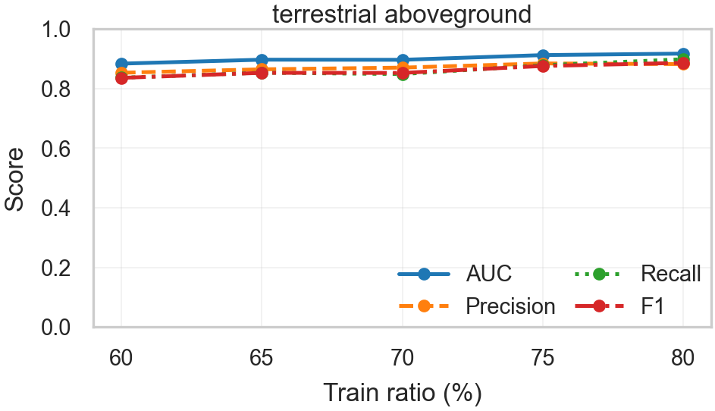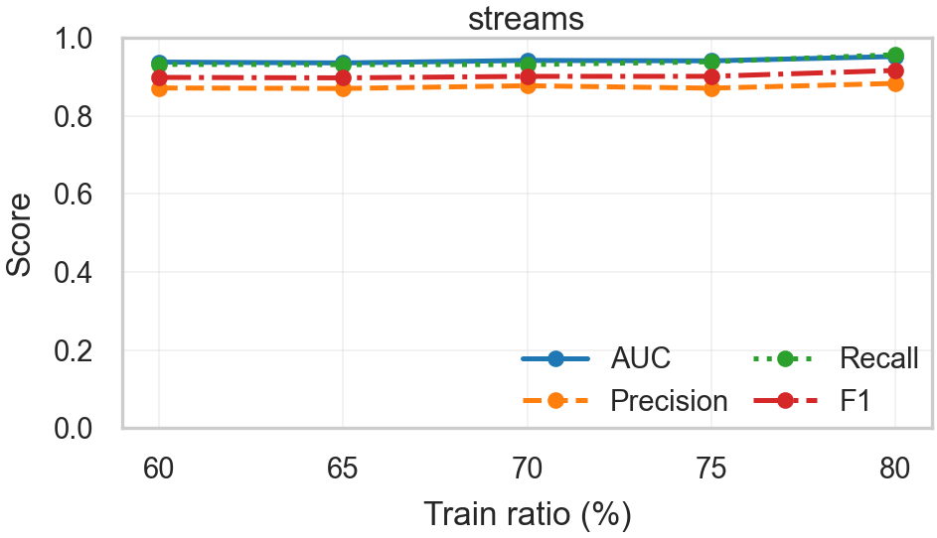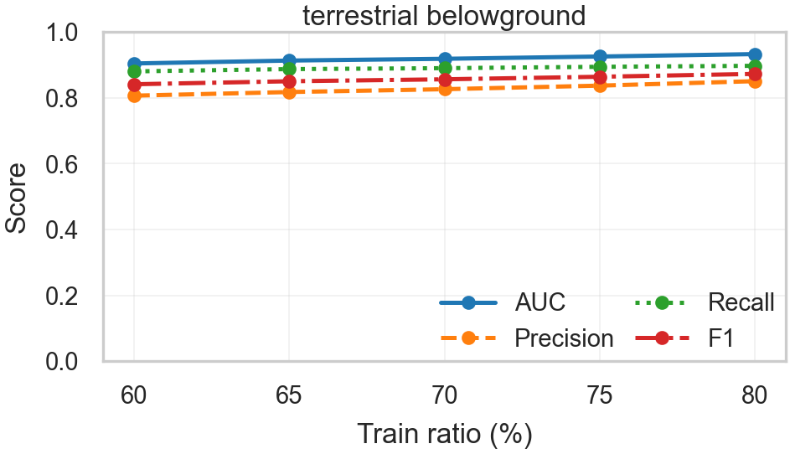
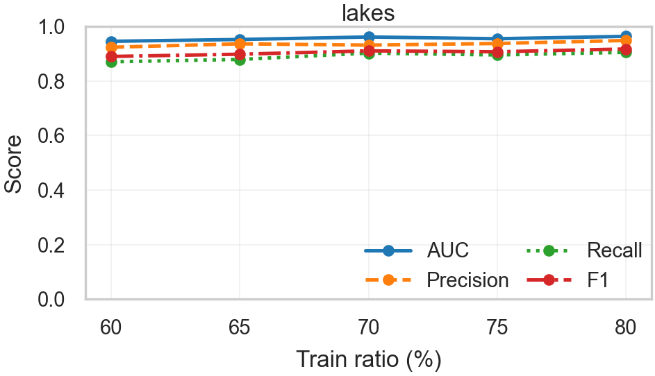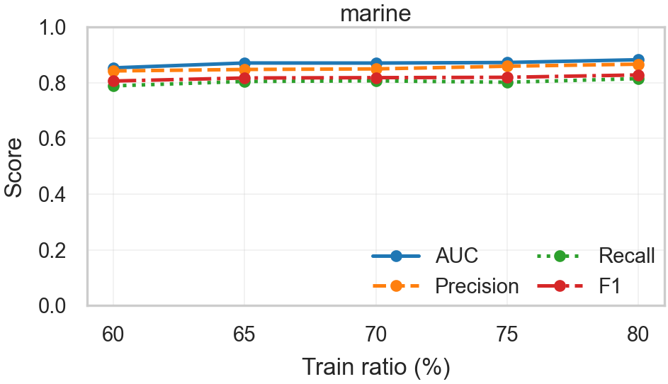
Figure 1. Each panel corresponds to one ecosystem type and plots four evaluation metrics—AUC (ranking ability), Precision (proportion of predicted links that are true), Recall (proportion of true links recovered) and F1 (harmonic mean of Precision and Recall)—against the training ratio expressed in percent (60–80). At each ratio we trained WLNM models and computed the metric for every food web in that ecosystem; the lines connect the mean score across food webs (and runs, when present), and points mark the five training fractions. Across ecosystems, curves are near-flat and close to the upper range of the scale, indicating that WLNM achieves consistently strong performance and that increasing the training fraction beyond 60% yields only modest improvements. Error bars are omitted here for compactness; a version with uncertainty bands is provided in the Supplementary Material.
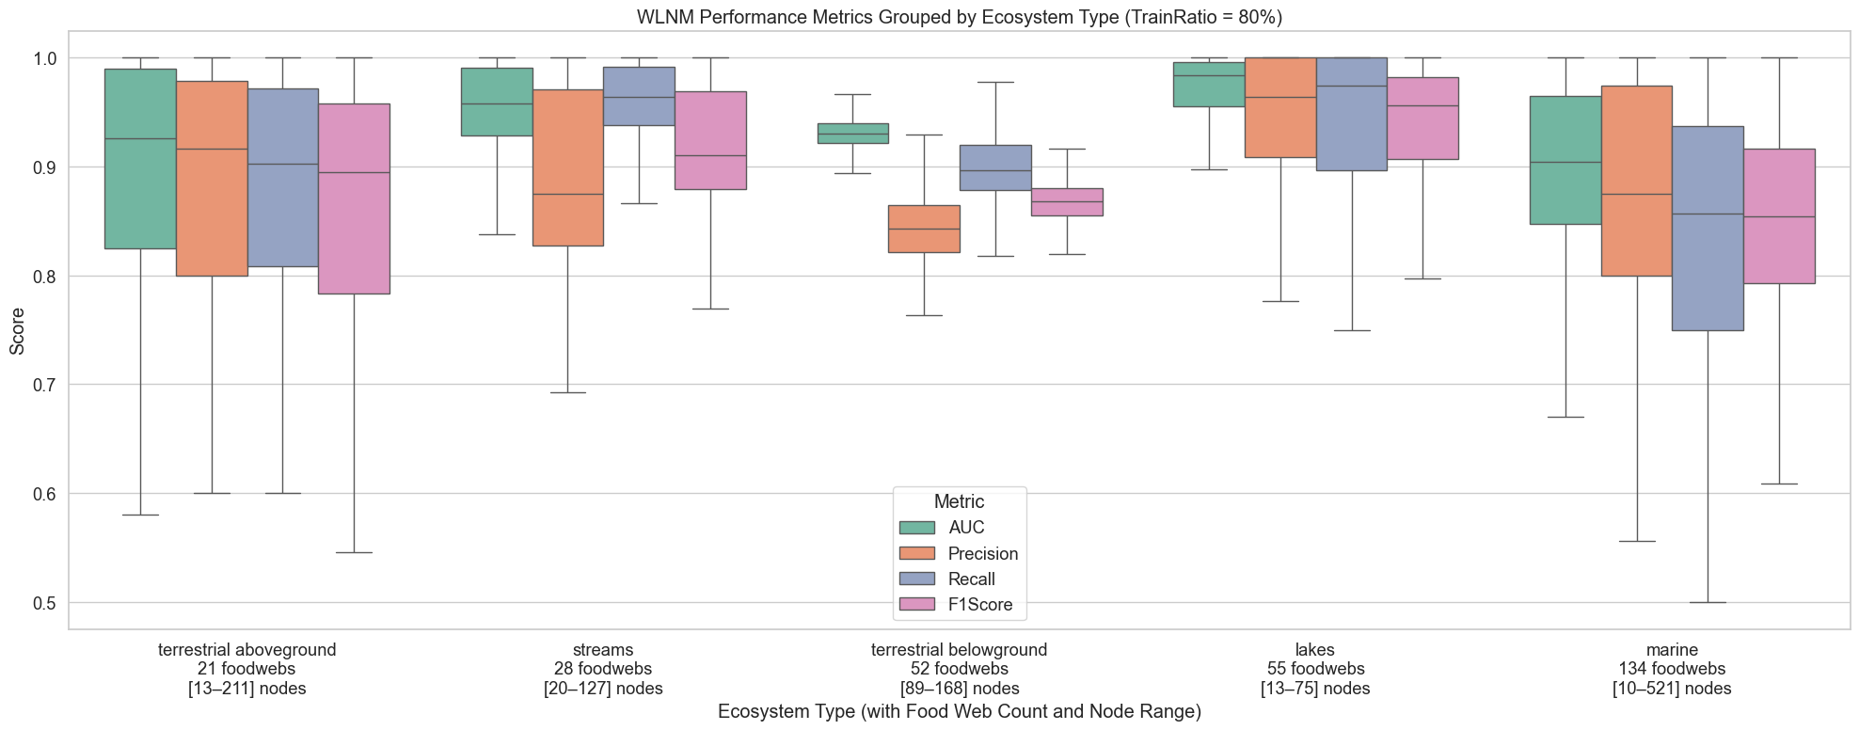
Figure 2. This figure shows how the Weisfeiler–Lehman Neural Machine (WLNM) performs across five ecosystem types when trained with 80% of observed links. Each boxplot represents the distribution of four evaluation metrics, AUC, Precision, Recall, and F1-Score, for a collection of food webs belonging to the same ecosystem category. The comparison reveals that performance is not uniform across ecosystems: for example, lakes and streams tend to show tighter distributions with higher average values, while marine food webs exhibit greater variability. This is important because it demonstrates that predictive accuracy depends not only on model configuration but also on the structural properties of the ecosystems themselves, such as food web size and complexity. The figure was generated by running the WLNM pipeline on subsets of food webs grouped by ecosystem, computing evaluation metrics for each run, and aggregating them into boxplots to visualize central tendency and variability.
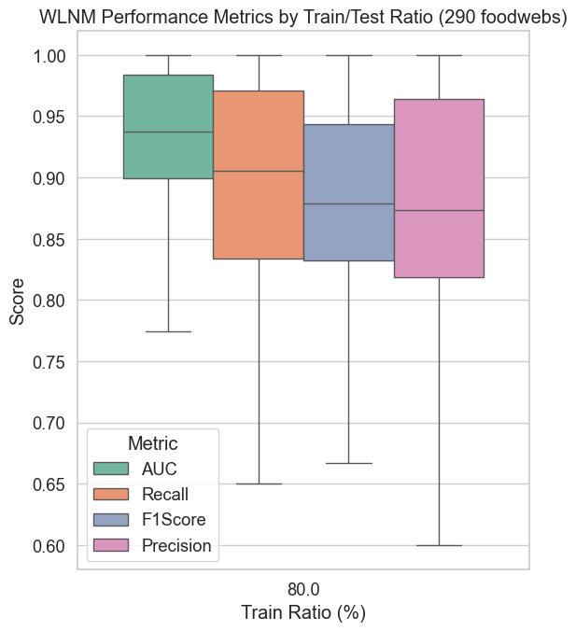
Figure 3. This figure summarizes the performance of the Weisfeiler–Lehman Neural Machine (WLNM) across all 290 food webs using an 80/20 train/test split. Each boxplot displays the distribution of four evaluation metrics, AUC, Recall, F1-Score, and Precision. The results indicate that WLNM achieves consistently high AUC values, suggesting strong discriminative ability, while Recall and Precision show greater variability across food webs. This is important because it highlights the trade-off between sensitivity (capturing true links) and specificity (avoiding false positives), and how performance can fluctuate depending on network size and structure. The figure was generated by training WLNM on 80% of each food web’s observed links, testing on the remaining 20%, and aggregating evaluation metrics from all runs into boxplots for visualization.
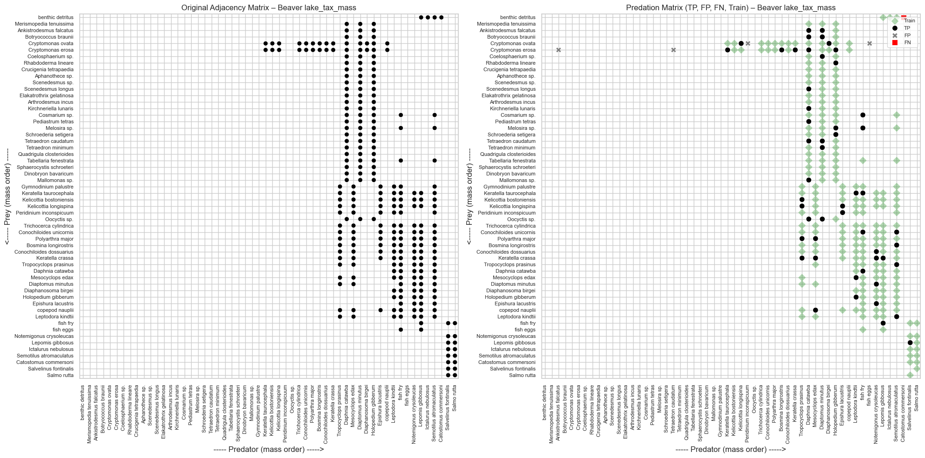
Figure 4. This figure compares the observed and predicted feeding interactions in the Baxver lake food web. The left panel shows the original adjacency matrix, where each black dot corresponds to an observed predator–prey link, with species ordered by body mass. The right panel overlays the model’s predictions on the same structure: green dots highlight true positives (links correctly predicted), red squares indicate false positives (predicted but not observed), black dots represent training links, and grey crosses mark false negatives (observed but missed). This comparison is important because it provides a visual validation of the model’s performance at the level of individual interactions, showing not only overall accuracy but also where systematic errors occur. The matrices were generated by training the Weisfeiler–Lehman Neural Machine (WLNM) on a subset of links from this food web, then testing the model’s predictions against the withheld interactions, with results displayed in a predator-by-prey grid.
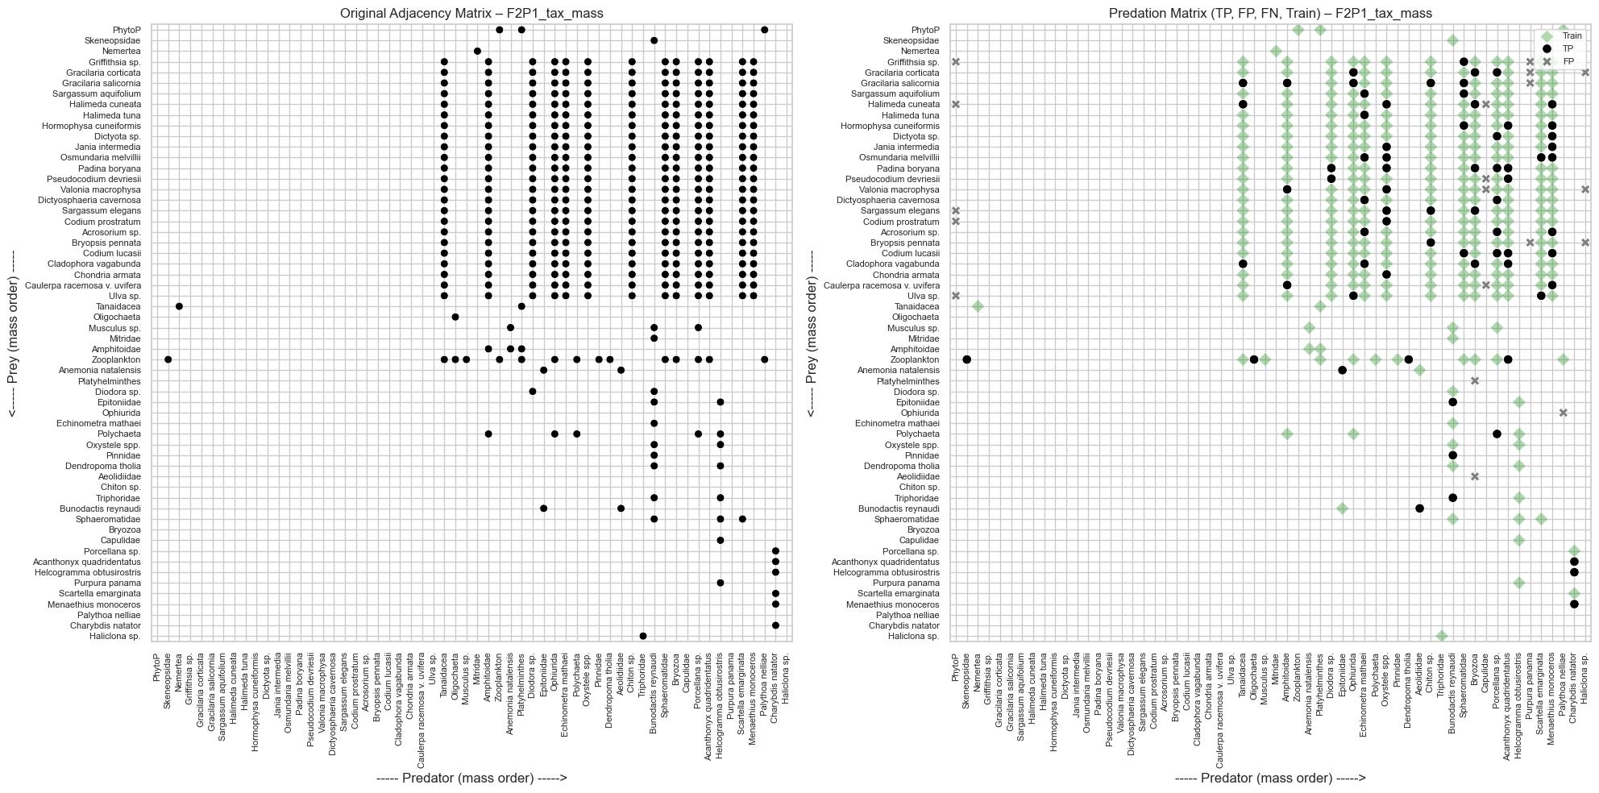
Figure 5. This figure presents a comparison between the observed and predicted predator–prey interactions in the TPP food web. On the left, the adjacency matrix displays all observed feeding links as black dots, with prey on the vertical axis and predators on the horizontal axis ordered by body mass. On the right, the predation matrix shows WLNM’s predictions relative to the observed data: true positives (green dots) indicate correctly predicted links, false positives (red squares) are predicted but not observed, training links (black dots) are those used for model fitting, and false negatives (grey crosses) represent observed interactions that the model failed to predict. This visualization is important because it reveals the model’s strengths and weaknesses at the interaction level, making it possible to identify systematic prediction patterns such as clusters of missed links or over-predictions. The figure was generated by training WLNM on a subset of interactions and testing its predictions against withheld links from the same food web.
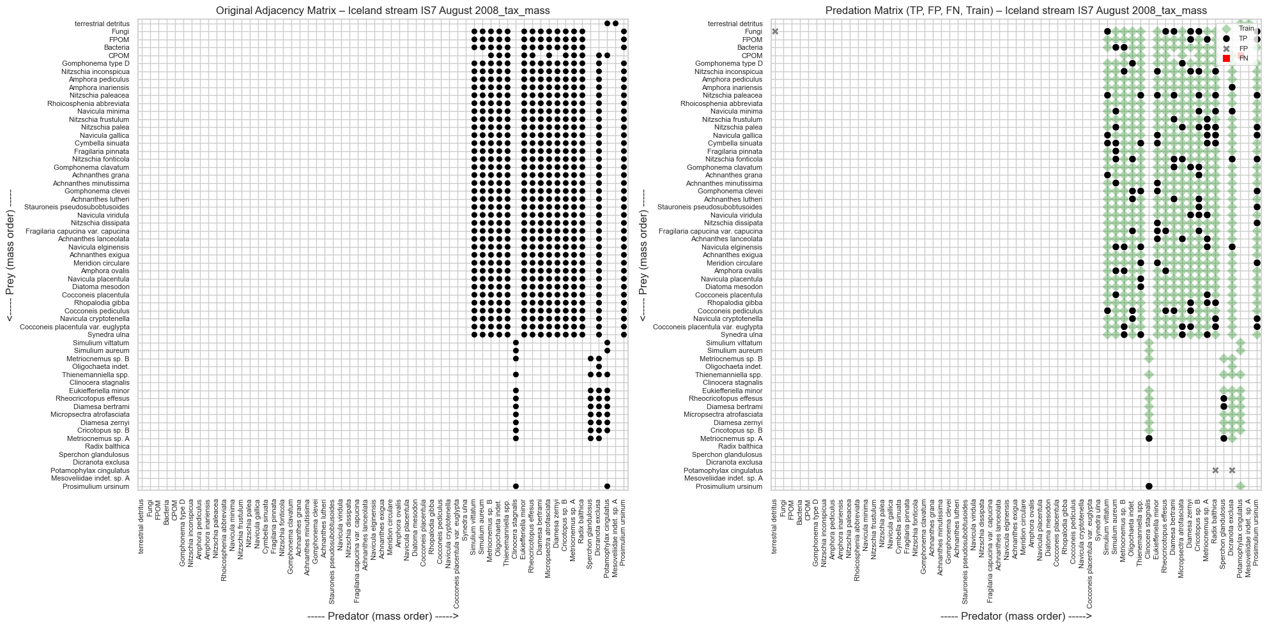
Figure 6. This figure compares observed and predicted feeding interactions for the Isolated stream 877 August 2003 food web. The left panel shows the adjacency matrix, with black dots indicating observed predator–prey links arranged by body mass. The right panel overlays WLNM’s predictions: true positives (green dots) are correctly predicted links, false positives (red squares) are predicted but not observed, black dots denote links used in training, and grey crosses indicate observed interactions the model failed to predict. This visualization is important as it highlights how effectively the model captures the feeding structure of this stream ecosystem, while also revealing systematic errors, such as clusters of missed or over-predicted links. The matrices were generated by training WLNM on a portion of the observed interactions and validating predictions against withheld links.
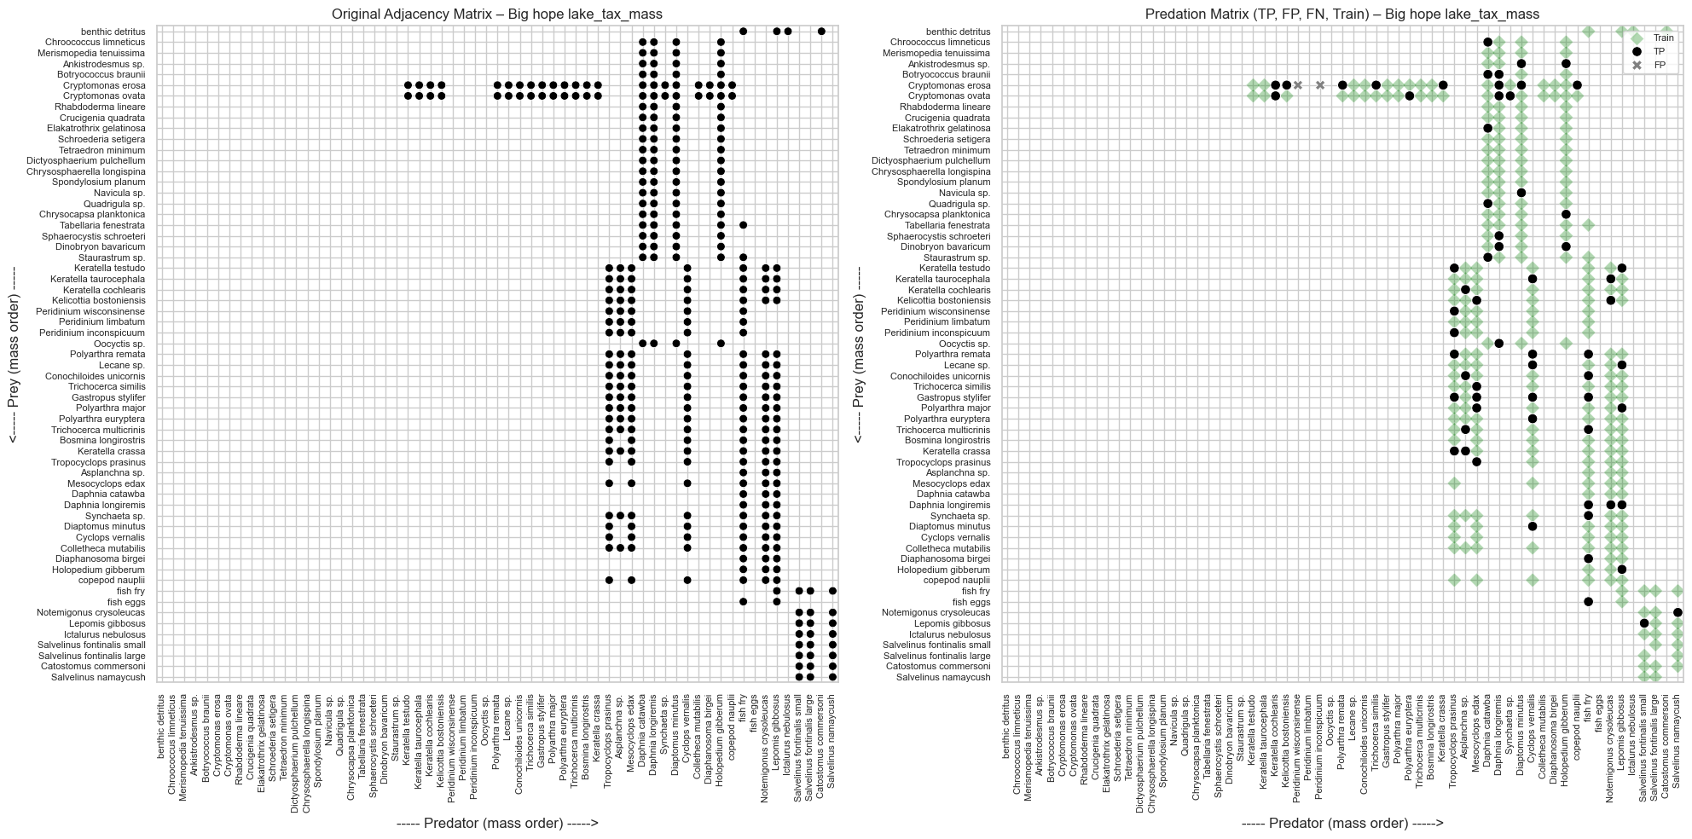
Figure 7. This figure presents the observed and predicted feeding interactions in the Big Hopu lake food web. The left panel shows the adjacency matrix of observed interactions, where black dots represent predator–prey links arranged by species body mass. The right panel overlays WLNM’s predictions: true positives (green dots) indicate links that were correctly predicted, false positives (red squares) represent predicted but unobserved links, training links (black dots) were used to fit the model, and false negatives (grey crosses) show observed interactions that the model failed to recover. This visualization is important because it highlights both the successes and errors of the model in capturing the trophic structure of this lake ecosystem. The figure was generated by training WLNM on a subset of observed interactions and testing its predictions against withheld links.
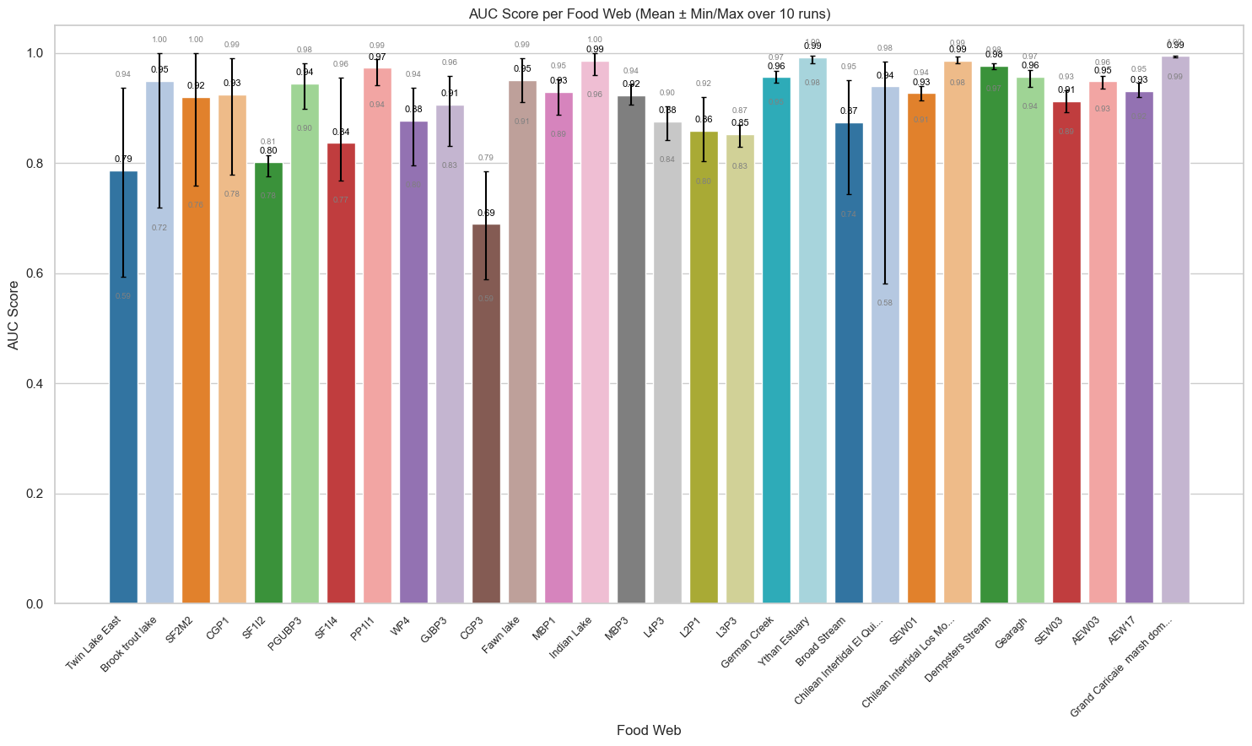
Figure 8. This figure shows the predictive performance of the Weisfeiler–Lehman Neural Machine (WLNM) measured by the Area Under the ROC Curve (AUC) across multiple food webs. Each colored bar represents a food web, with the height indicating the mean AUC score over 10 independent runs. Error bars display the minimum and maximum values obtained, providing a sense of variability and robustness. Most food webs achieve high AUC scores close to 1.0, suggesting strong discriminative ability of the model, while a few show lower values, highlighting networks where predictions are more challenging. This analysis is important because it demonstrates not only average model performance but also its consistency across repeated runs, ensuring reliability of the results. The figure was generated by training and testing WLNM 10 times on each food web and summarizing the distribution of AUC values.
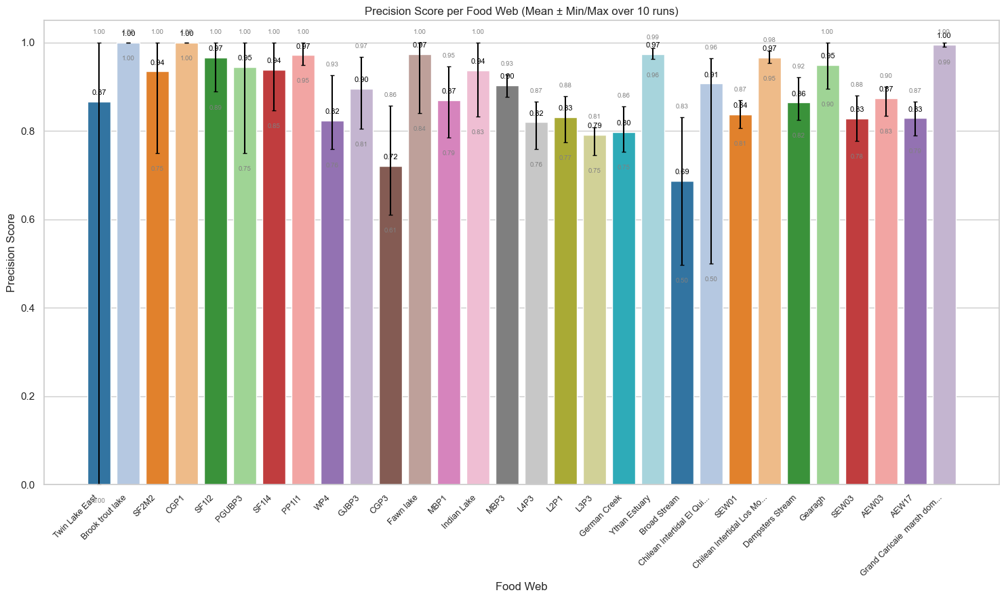
Figure 9. This figure presents the Precision scores of the Weisfeiler–Lehman Neural Machine (WLNM) across multiple food webs. Each colored bar corresponds to a single food web, with the bar height showing the mean Precision score over 10 independent runs, while error bars represent the minimum and maximum scores obtained. Precision reflects the proportion of predicted links that are actually correct, meaning high values indicate the model is effective at minimizing false positives. While many food webs reach near-perfect Precision, some exhibit more variability, suggesting that prediction difficulty differs depending on food web structure and size. This analysis is important as it complements recall-based evaluations, ensuring that model predictions are not only sensitive but also specific. The figure was generated by running WLNM 10 times per food web, computing Precision in each case, and summarizing results using mean and range values.
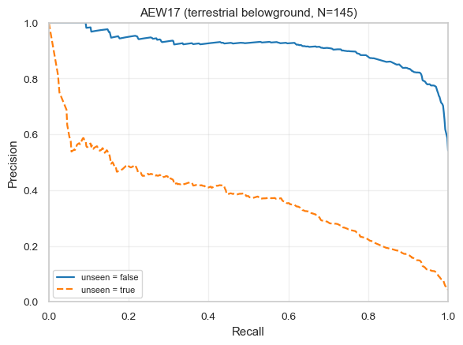
Figure 10. This figure displays Precision–Recall (PR) curves for the AEW17 terrestrial belowground food web (N = 145 nodes). The solid blue line corresponds to links included during training (unseen = false), while the dashed orange line represents predictions on unseen links withheld for testing. PR curves are useful because they show the trade-off between Precision (avoiding false positives) and Recall (capturing true positives) across different classification thresholds. The figure reveals that while WLNM performs strongly on seen interactions, its performance declines on unseen links, reflecting the challenge of generalizing predictions to unobserved parts of the network. The curves were generated by computing Precision and Recall at varying decision thresholds on both training and testing sets.
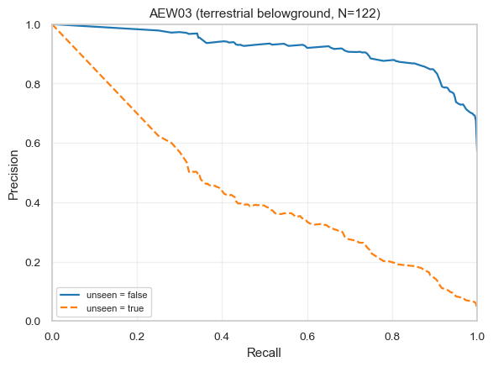
Figure 11. This figure shows Precision–Recall (PR) curves for the AEW03 terrestrial belowground food web (N = 122 nodes). The solid blue line reflects model performance on links included in the training data (unseen = false), while the dashed orange line shows predictions on links withheld during testing (unseen = true). PR curves reveal the balance between Precision, the proportion of predicted links that are correct, and Recall, the proportion of observed links recovered, across classification thresholds. The results indicate that WLNM achieves consistently high Precision and Recall on training data, but its performance drops substantially on unseen links. This highlights the challenge of generalizing link prediction to unobserved interactions in large, complex food webs. The curves were generated by evaluating model predictions over a range of thresholds for both training and test sets.
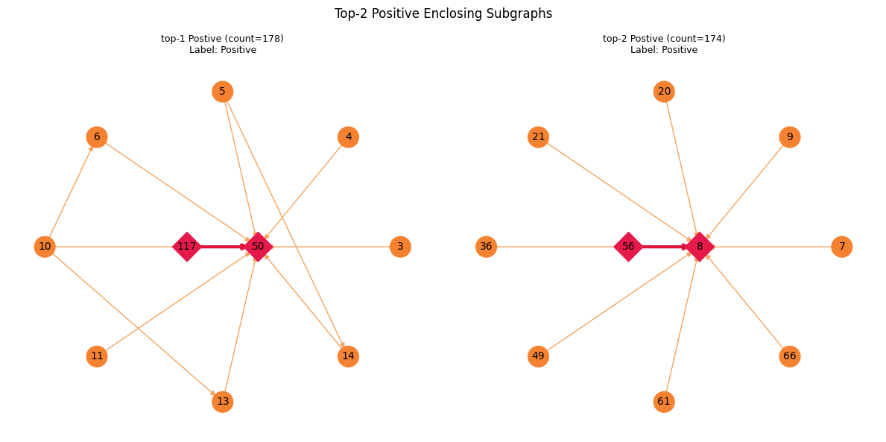
Figure 12. This figure shows the two most frequent positive enclosing subgraphs identified during the WLNM encoding process. Each subgraph centers on a target link (highlighted by the red diamond nodes), with orange circular nodes representing neighboring species included in the enclosing structure. The left subgraph (count = 170) and the right subgraph (count = 174) represent recurring local patterns around predator–prey interactions labeled as positive. Visualizing enclosing subgraphs is important because they reveal the building blocks used by WLNM to learn predictive features: they capture the structural context of interactions, including shared neighbors and connectivity patterns. By analyzing these subgraphs, we can better understand why the model classifies certain pairs as likely interacting. These subgraphs were generated by extracting local neighborhoods around positive links and encoding them with the Weisfeiler–Lehman labeling procedure.
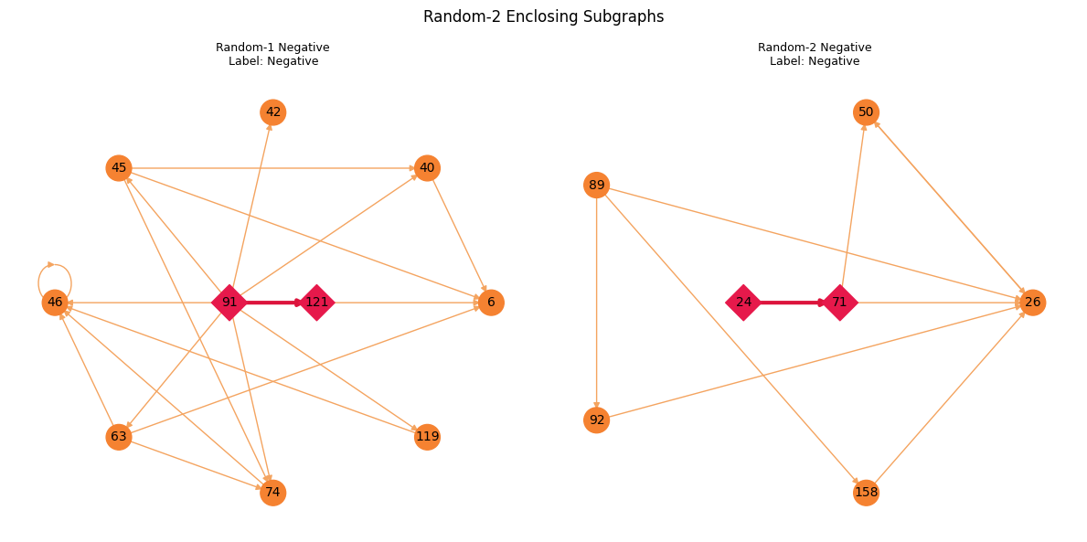
Figure 13. This figure displays two examples of enclosing subgraphs corresponding to negative samples, where the central pair of species (shown as red diamond nodes) does not represent an observed predator–prey interaction. The surrounding orange circular nodes represent the local neighborhood extracted to form the enclosing subgraph. These negative subgraphs are important because they provide contrastive training examples for the Weisfeiler–Lehman Neural Machine (WLNM), allowing the model to learn not only the structural patterns of true interactions but also those of non-interacting pairs. The two examples shown here were randomly selected from the pool of negative samples, highlighting the structural diversity of non-links in food webs. These subgraphs were generated by sampling species pairs without observed interactions, extracting their surrounding neighborhood, and encoding them using the Weisfeiler–Lehman labeling procedure.
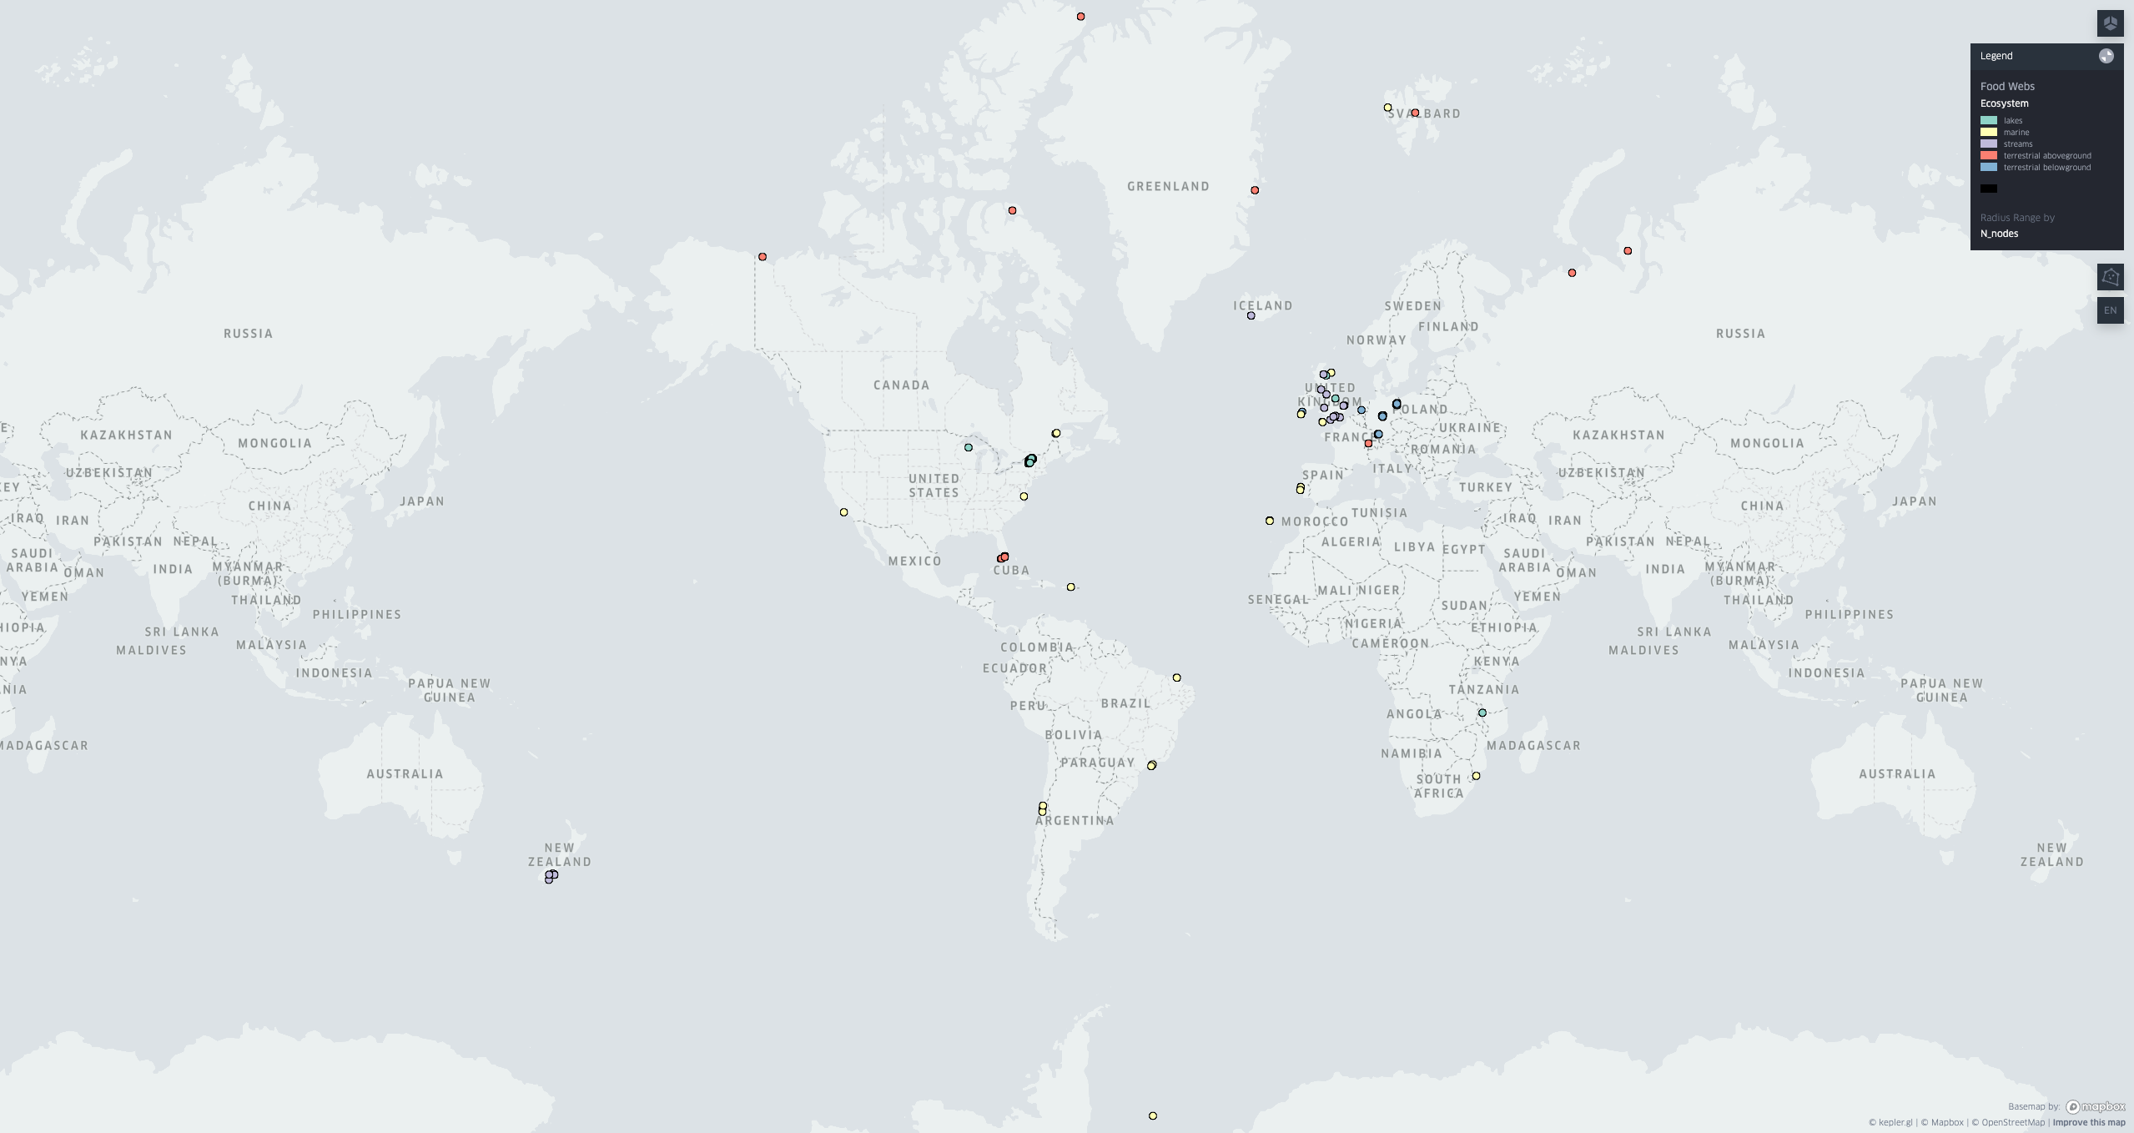
Figure 14. This figure presents a global map showing the geographic distribution of the 290 food webs analyzed in this study. Each point corresponds to a food web location, with color-coded symbols indicating the ecosystem type (terrestrial aboveground, streams, lakes, marine, or terrestrial belowground). The map highlights the strong geographic diversity of the dataset, spanning multiple continents and biomes, which ensures that the results are not biased toward a single region or ecosystem. This diversity is important because it allows the model to be tested under a wide range of ecological contexts, improving the robustness and generality of the findings. The map was generated by geocoding the food web datasets and visualizing them with a geographic information system (GIS) tool, using consistent color and symbol coding to distinguish ecosystem categories.
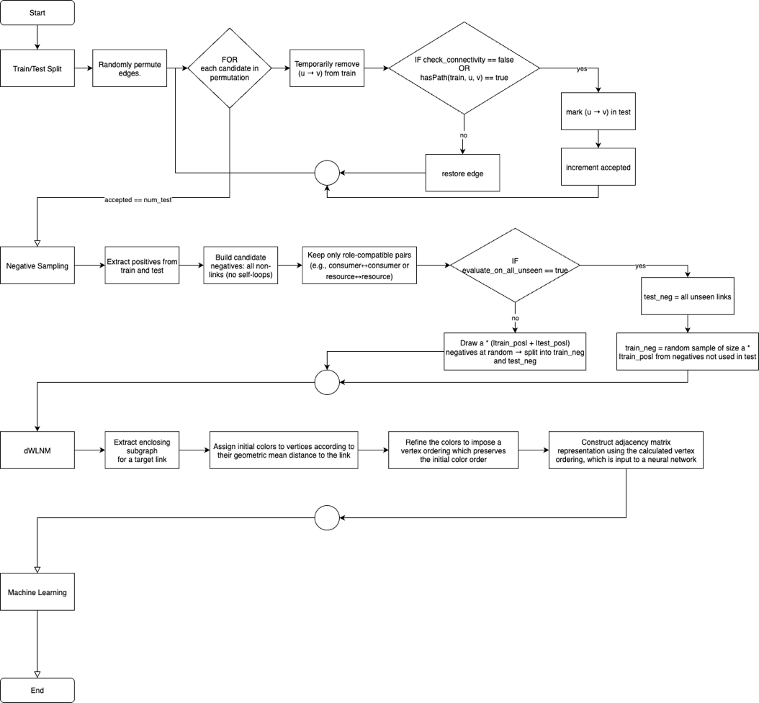
Figure 15. This figure illustrates the full workflow of the Weisfeiler–Lehman Neural Machine (WLNM) pipeline as applied to food web link prediction. The process begins with splitting the network into training and test sets, followed by negative sampling where ecologically meaningful non-links are selected. Next, enclosing subgraphs are extracted around candidate pairs, encoded using Weisfeiler–Lehman relabeling, and transformed into feature vectors. These representations are then used to train and evaluate a machine learning classifier. The flowchart is important because it provides a clear and systematic overview of how the pipeline operates, showing where ecological constraints (e.g., body mass filtering in negative sampling) are introduced and how subgraph-level encoding leads into predictive modeling. The diagram was generated by formalizing the methodological steps into a process flow to ensure clarity and reproducibility.

Results
Performance of eight WLNM variants was evaluated on a corpus of food webs spanning multiple ecosystem types. The variants considered were the original WLNM (baseline), WLNM with an ecology-aware negative links strategy, WLNM with directed subgraph expansion and encoding, and the combination of directed encoding with the negative strategy. Unless stated otherwise, an 80% training ratio was used as the primary setting, repeated executions within each food web were averaged to yield a single estimate per web, and summary statistics were computed across the full set of webs.
For each variant, per-web Area Under the ROC Curve (AUC), Precision, Recall, and F1 were computed and inspected as functions of network size (number of nodes) and ecosystem type. Comparisons among variants were performed at the food-web level using paired analyses; distributional shifts were summarized by median (and interquartile range) differences with 95% confidence intervals obtained by bootstrap resampling, and statistical significance was assessed with paired Wilcoxon signed-rank tests. Effect sizes were reported using Cliff’s delta to complement p-values. To facilitate interpretation, reference lines corresponding to random-classifier AUC (0.5) and the cross-web mean for each metric were overlaid on the point plots, and ecosystem-stratified views were provided where relevant.
All figures report one point per food web at the chosen training ratio, ensuring equal weighting across webs and preventing repeated splits from inflating sample sizes. Where appropriate, sensitivity to network size was examined by relating scores to node count, and robustness to stochastic variation was addressed by averaging across repetitions before aggregation. Detailed per-web values are provided in supplementary tables; main text figures present aggregated patterns and paired differences that are directly comparable across the four variants.

Predictive Performance Across Ecosystems
We evaluated the WLNM model on 30+ food webs representing diverse ecological systems. The model consistently achieved high predictive performance across datasets, with mean AUC values exceeding 0.90 for the majority of networks. Notably, several food webs such as Brook Trout Lake, Grand Caricaie, and AEM17 achieved perfect or near-perfect AUC (1.00 ± 0.00), indicating exceptional discriminative ability.
AUC variability was more pronounced in mid-sized and sparse food webs such as CGP1 and Broad Stream, likely due to reduced link density and higher noise-to-signal ratios. These results suggest that WLNM maintains robust performance even in relatively challenging ecological scenarios.

Precision Score Distribution
In addition to AUC, we evaluated precision scores across 10 randomized runs. While AUC reflects global ranking quality, precision emphasizes how often high-confidence predictions are correct, a critical metric for ecological applications where false positives can mislead inference.
- High precision was observed in food webs such as Brook Trout Lake, AEM17, and Grand Caricaie, which achieved mean precision scores of 1.00, indicating near-perfect predictions at the chosen threshold.
- Lower and more variable precision was observed in webs like CGP1 and Broad Stream, where standard deviation exceeded 0.3. This suggests the presence of highly ambiguous or noisy interactions, challenging the classifier’s confidence calibration.
These results affirm that ecological metadata and role-aware sampling reduce spurious link predictions in well-structured food webs.

Precision–Recall Trade-offs
Precision–recall curves highlight the model's sensitivity across the full recall spectrum. Food webs with strong trophic hierarchies, such as SF12, GUBP3, and Indian Lake, exhibited steep precision drop-offs at high recall, indicating difficulty in recovering less obvious interactions without increasing false positives.
Conversely, ecosystems like Brook Trout Lake and Ythan Estuary maintained high precision even at high recall, underscoring the model’s ability to generalize well in structurally cohesive networks.
We also compared performance under two test regimes:
- Unseen=false (solid lines): test links sampled randomly
- Unseen=true (dashed lines): test links sampled among all non-observed links
The model performed better under unseen=false as expected, but still retained reasonable generalization under the more challenging full-unseen setup.

Species Most Prone to False Positives
To interpret model behavior, we analyzed false positive links by species. Across many networks, species with high generality (e.g., omnivores or basal resources) were overrepresented in FP predictions. For instance:
- In Twin Lake East, species like Disphania ambigua appeared frequently in FP links.
- In CGP1, generalist predators like Lota lota and Sander vitreus accounted for many FP interactions.
- Networks like Brook Trout Lake and Indian Lake showed no significant FP-prone nodes, aligning with their high overall performance.
This analysis suggests that model overconfidence in well-connected or taxonomically ambiguous species may inflate FP rates, despite strong global metrics.

Structural Discrepancies: Adjacency vs Predation Matrices
To assess the alignment between inferred links and ecological realism, we compared each food web’s adjacency matrix (raw predicted links) with its predation matrix (TP links recovered from the test set).
Figure 5 displays these pairwise comparisons, highlighting how many of the model’s predictions correspond to biologically validated interactions:
- In structured webs like Brook Trout Lake or Indian Lake, the adjacency matrix aligns tightly with the TP matrix, most predicted links matched actual predation relationships.
- In contrast, food webs like CGP1 or Dempsters Stream exhibit a larger set of false positives, where adjacency matrices contain additional links not supported by test data. This may be due to:
  - Weak trophic stratification
  - Sparse training data
  - Role ambiguity (e.g., species with dual consumer/resource roles)
This analysis underscores the need to incorporate biological constraints during training and supports our approach of using role-filtered negative sampling.

Methodology

Introduction:
Ecologists often assemble “food webs” to describe who eats whom in an ecosystem. These networks provide insights into energy flow, stability, and the ways disturbances ripple through communities. Yet most food webs are incomplete: many plausible feeding interactions are missing because they are difficult to observe or rarely recorded. The central question in this study is whether information from known links can be used to score other pairs of species that might also interact, so that fieldwork and curation can concentrate on the most promising candidates.
Predicting missing links is a long-standing topic in data science, with applications that range from recommending friends or products to filling gaps in biological interaction maps. A natural starting point is to use simple rules based solely on network structure, for example, assuming that two nodes are more likely to connect if they share many neighbours. Such rules are computationally efficient and can work well in social settings, but they do not transfer reliably across domains. In biological networks, and especially in food webs, these rules often fail because feeding is directional and constrained by traits: predators consume prey, not the other way around, and body size and trophic role make some pairs much more plausible than others.
These differences are important. Many widely used heuristics implicitly treat networks as undirected or symmetric, rewarding patterns such as “common neighbours” that have a clear interpretation in friendship graphs but a weak ecological meaning when arrows indicate prey-to-predator flow. Other methods that explore more distant connections in the network may perform better in technical benchmarks, but they are computationally costly and still ignore basic constraints such as role compatibility or the strong influence of body size on feeding interactions.
The present study builds on the idea that useful signals for link prediction are often local. Instead of applying hand-crafted rules, the method focuses on the small neighbourhood around each candidate pair of species and learns which local wiring patterns are most likely to accompany real feeding interactions. The Weisfeiler–Lehman Neural Machine (WLNM) framework is adapted to directed trophic networks so that arrow direction is respected at every step. Around each candidate pair, a small directed subgraph is extracted, placed into a stable and comparable order, and then used to train a lightweight neural classifier to estimate whether that pair is likely to represent a true interaction.
Two ecological design choices are central to this adaptation. First, negative examples (pairs treated as non-interactions during training) are constructed in a way that filters out biologically impossible cases, such as consumer-to-consumer or resource-to-resource directions when these violate trophic roles. This keeps the learning signal focused on plausible alternatives. Second, the train–test splits are designed to reflect the reality of sparse food webs.
The approach is evaluated across a large collection of food webs spanning lakes, marine, streams, terrestrial aboveground, and terrestrial belowground ecosystems. Performance is assessed using metrics suited to rare positives, such as ROC–AUC and Average Precision, and complemented with precision–recall summaries at a fixed threshold for interpretability. Across ecosystems, the directed WLNM with ecology-aware negatives and rare-link training provides consistent gains over undirected baselines and generic heuristics, while remaining simple and reproducible.
Taken together, the contribution is practical and domain-driven: a link prediction pipeline that keeps the model modest but the representation faithful to trophic direction, incorporates basic ecological priors, and is evaluated under splits that reflect the kinds of missing links of greatest interest to curators. The result is a ranked list of candidate interactions for each food web that can guide future sampling and improve the completeness of ecological network data.

Preliminaries
This study considers food webs as directed networks that record who eats whom. Each species is a node and each feeding interaction is an arrow from prey to predator. Each web is stored as a square table where a “1” in row u and column v indicates that species u is eaten by species v; a “0” indicates no recorded interaction in that direction. When available, attributes such as body mass and taxonomy are aligned with this table so that every species retains the same position across steps.
The task is link prediction: estimating how likely it is that a particular prey–predator pair represents a true interaction missing from the data. A candidate pair is any ordered pair without a recorded arrow from the putative prey to the putative predator. Rather than analysing the entire network at once, the method concentrates on the small neighbourhood around each candidate pair. Here, “neighbourhood” denotes the set of species within a few steps of either member of the pair when following arrow directions forward or backward. Working locally keeps computation feasible and focuses the model on wiring patterns most relevant to the decision.
Many classical approaches to link prediction rely on simple scores derived from network structure, such as rewarding two species that share many neighbours. These rules can be quick and surprisingly strong in social graphs, but they often blur direction or assume symmetry. In food webs, direction and traits matter: arrows run from prey to predator, and roles and body size make some directions far more plausible than others. Consequently, in this study such heuristics serve as context rather than the core method.
The approach is based on the Weisfeiler–Lehman Neural Machine (WLNM), adapted to trophic networks so that direction is respected throughout. The key idea is to learn directly from the local wiring pattern around each candidate pair instead of hand-picking a rule. For every pair under consideration, a small directed subgraph centred on that pair is extracted, its nodes are placed into a stable, comparable order, the ordered connections are converted into numbers, and a modest neural network is trained to learn which patterns tend to accompany real feeding interactions.
Enclosing subgraph extraction. For a given pair, nearby species are gathered by expanding outwards in small steps from the two endpoints, following the network’s arrows along prey→predator and predator→prey directions as appropriate to the task. The neighbourhood is capped at a fixed size so that all examples share the same maximum number of nodes. If the neighbourhood grows too large, the most central nodes are retained and the farthest are dropped; if it is smaller than the cap, its true size is kept and processing proceeds. This “zoomed-in” view captures the immediate context in which real interactions tend to appear, without being swamped by the rest of the web.
Subgraph pattern encoding. Learning algorithms require a consistent input ordering so that two neighbourhoods with the same shape appear identical even if species labels differ. This is achieved with colour refinement, commonly referred to as the Weisfeiler–Lehman (WL) procedure. All nodes start with temporary colours, and at each round a node updates its colour based on the multiset of colours observed in its immediate neighbours. Nodes playing similar structural roles converge to the same final colour; nodes in different roles diverge. To make this useful for link prediction, the procedure is seeded with an initial ordering that reflects distance to the candidate pair so the two endpoints are always distinguished and the notion of “closer versus farther” is preserved. After refinement, the final colours provide a consistent node order. The ordered subgraph is then converted into a fixed-length numeric vector by reading the upper half of its connection table. The direct entry that would reveal whether the pair itself is linked is excluded so the model cannot cheat by memorising that cell.
Neural network learning. A small feed-forward classifier is trained on vectors from known positives and carefully constructed negatives. Positives are recorded feeding interactions in the training split. Negatives are pairs treated as non-interactions for learning, formed with ecological safeguards so that biologically impossible directions are filtered out before sampling. The network is intentionally lightweight; the aim is for the representation to carry the signal rather than to rely on a large model. Once trained, the network assigns a score between zero and one to each candidate pair in the test split, interpreted as the likelihood of that interaction given the observed local structure.
Two practical notes tie these pieces together. First, the neighbourhood-size parameter controls a natural trade-off: larger neighbourhoods can represent more distant patterns but are costlier to compute, while smaller neighbourhoods are faster and often sufficient because the most useful cues are local. Second, the encoding step is efficient in practice because colour refinement converges in a few rounds on these small subgraphs, and extraction for different pairs can be run independently.
These definitions and conventions establish the method developed and evaluated in the remainder of the paper. They enable a description of the pipeline without heavy notation while keeping the discussion precise and faithful to trophic direction and basic ecological constraints.

Data acquisition and preparation
A corpus of 290 food webs from the GATEWAy database curated by Ulrich Brose and collaborators was assembled and converted from comma-separated files into a consistent analysis format. Each web is stored in a single MATLAB file containing a directed interaction matrix net and three aligned species-level attributes: a taxonomy vector of names, a mass vector with representative body mass, and a role label when available. The matrix records prey→predator direction: a 1 in row i, column j indicates that species i is eaten by species j; a 0 indicates no recorded link in that direction. This convention preserves arrow direction throughout and keeps network structure and metadata aligned.
To support experiments across many webs, a catalogue file with short names and ecosystem tags is maintained and iterated over, loading the corresponding .mat file from disk (for example, AEW04_tax_mass.mat or a Grand Caricaie marsh web saved under a descriptive name). On load, each dataset is standardised to ensure a one-to-one alignment between the network and its attributes. The interaction matrix is verified to be square and strictly binary; if sources contain counts or weights, values are binarised to 0/1 because the objective is to model presence versus absence of feeding interactions rather than frequency. Accidental self-loops are removed because they do not represent meaningful trophic links. Direction is not symmetrised at this stage.
Names, masses, and roles are then reconciled so that all vectors match the matrix indices exactly. Species names are cleaned once per web to remove trivial differences such as stray spaces or punctuation, and the cleaned names define the final row and column order. The taxonomy, mass, and role vectors are aligned to this order. When body mass is missing in the sources, it is left explicitly missing rather than imputed, allowing later steps to use or ignore the field without hidden assumptions. Checks confirm that every label appears exactly once, that attribute vector lengths match the matrix size, and that any all-zero rows or columns are intentional (for example, basal resources) rather than artefacts of misalignment.
The conversion from CSV to .mat is reproducible. For each web, the edge list is parsed under the prey→predator convention, a dense index keyed by the cleaned names is constructed, and the corresponding matrix cells are set to one. Body mass and role information are attached by matching on the same names. Acyclicity is not enforced; trophic cycles present in the sources are retained because they can reflect real ecological structure. Rare, poorly connected species are also retained, since learning from sparse regions is central to the study.
Finally, this clean, aligned state is saved and a minimal log is written per web, noting the file loaded, the number of species, the number of links after removing self-loops, and whether any names or masses were corrected or left missing. By fixing direction, binarising links, and enforcing a consistent species order at the data stage, all subsequent procedures—splitting known interactions into training and testing sets, constructing ecologically plausible non-interactions, extracting local neighbourhoods, and training the classifier—operate uniformly across ecosystems, making the results comparable and reproducible.

How I split links for training and testing
For each food web, the observed feeding interactions were divided into a training set, used to fit the model, and a test set, used exclusively for evaluation. The split was controlled by a single proportion indicating the share of observed links retained in training. Throughout, links preserved their prey→predator direction, and self-loops were excluded because they are not meaningful trophic interactions.
The default split was random at the level of directed links. The procedure began by listing all recorded prey→predator pairs in the matrix and shuffling this list. Links were then moved from training to testing one by one until the requested test size was reached. When the connectivity safeguard was disabled, a link was moved as soon as it was selected. When the safeguard was enabled, a link was moved only if removing it from the training matrix still left at least one path from the same prey to the same predator through other species. This check prevented the training network from fragmenting in unrealistic ways while still allowing evaluation on links unseen during learning. For very small webs, the safeguard was disabled automatically to avoid rejecting too many links and failing to form a test set. The number of removals attempted and accepted was recorded to make this choice transparent.
Each split produced two adjacency matrices of the same size as the original web: one for training and one for testing. A 1 in the training matrix indicated a link available to the model during learning; a 1 in the test matrix indicated a link held out for evaluation. By preserving direction, applying a simple reachability safeguard when appropriate, and optionally supporting rare-link configurations, this splitting procedure matched ecological intuition while remaining reproducible and straightforward to apply across many webs.

Constructing non-interactions that are ecologically plausible
Supervised learning requires counter-examples as well as examples. For each food web, a set of species pairs was constructed for the model to treat as “non-interactions” during training and testing. The process began from the training and test matrices produced by the split step, listing all ordered prey→predator pairs not recorded as links. Negatives were then sampled from this pool under controlled rules.
To avoid trivial cases, a trophic-role feasibility check was applied so that candidate negatives respect feeding direction: the putative prey must be a resource and the putative predator a consumer. This keeps the learning problem focused on biologically plausible alternatives rather than obviously impossible pairs. The ratio of negatives to positives was kept near 2:1 so that classes remain imbalanced yet learnable. When a web was extremely sparse and the role filter yielded too few negatives, a back-off strategy was used: the ratio was reduced first, and only as a last resort was the filter relaxed to sample from all remaining unseen pairs. These choices were logged so that any relaxation is transparent at evaluation time.
For fairness on the evaluation side, the same logic was applied to the test set: a held-out set of plausible negatives of comparable size was drawn instead of treating every unseen pair as negative.

Focusing on each candidate pair’s local neighbourhood
Rather than exposing the model to the entire web, the method focuses on the small patch of network that most directly surrounds the pair under consideration. The centre of this patch is the ordered pair prey→predator. From the prey side, expansion proceeds “forward” along arrows to its immediate predators; from the predator side, expansion proceeds “backward” along arrows to its immediate prey. This yields a first ring of neighbours capturing two core ecological motifs: other species that also eat the candidate prey, and other species that are eaten by the candidate predator. The expansion is then repeated once more so that the neighbourhood reaches at most two steps from the pair, which is sufficient to include patterns such as shared prey-of-prey and shared predator-of-predator without pulling in the entire web.
Direction is preserved at every step. Expanding forward from the prey maintains the meaning “who might eat this organism,” and expanding backward from the predator maintains the meaning “what this organism might eat.” This asymmetric, two-sided growth is important for trophic networks because the same triangle of species can imply very different interactions depending on arrow direction. To avoid recounting the same connections and to keep growth bounded, links already explored are tracked and skipped on later passes. Nodes are accumulated in a stable order based on the time of first discovery during directed expansion, ensuring that two identical neighbourhoods are represented consistently even if species were listed differently in the original dataset.
The neighbourhood has a fixed budget of (K = 10) species. If the expansion would exceed this budget, the earliest, most central discoveries are retained and the farthest discarded so that the patch remains focused on the immediate context of the pair. If the neighbourhood is smaller than (K), processing proceeds with its true size rather than introducing artificial nodes. Alongside topology, the hop distance from the centre is recorded for every collected edge; this later enables down-weighting of edges that are two steps away relative to edges adjacent to the candidate pair. Finally, although the presence or absence of the pair’s own arrow is part of the original web, it is treated as “unknown” within the neighbourhood so the model cannot rely on that single cell; the exclusion is applied in the next stage when the neighbourhood is converted into numeric form.

Turning neighbourhoods into numbers the model can learn from
To make small network patches readable by a learning algorithm, each neighbourhood is converted into a single, fixed-length vector. The first safeguard hides the answer the model is supposed to infer: if the candidate pair already has an observed arrow, that arrow is temporarily removed within the neighbourhood while keeping the two species in fixed, leading positions. This prevents the classifier from shortcutting the task by inspecting that one entry, yet anchors the representation on the same focal pair every time.
A stable node order is then imposed so that two neighbourhoods with the same shape appear identical to the model even if species are listed differently. Colour refinement (a Weisfeiler–Lehman procedure) is used, seeded by distance from the candidate pair. The two endpoints start with the smallest colour, nodes one hop away start with a larger colour, and nodes two hops away larger still. At each refinement round, every node updates its colour by summarising the multiset of colours among its immediate neighbours. After a few rounds, colours stabilise. Nodes that play the same structural role converge to the same final colour; nodes that differ in role diverge. When ties remain, a canonical relabelling is applied so the final order is unique. Two invariants important for learning are thereby guaranteed: the focal pair always occupies the first two positions, and “closer” structural roles consistently precede “farther” ones.
With the ordering fixed, the ordered connections are translated into numbers. A connection table is built for the neighbourhood’s nodes, assigning larger weights to edges that lie closer to the candidate pair. In practice, edges one hop from the pair receive higher values than edges two hops away, while edges beyond this local ring are excluded by design. The table is then symmetrised before readout. Symmetrisation keeps the input compact and comparable across examples; direction is not discarded, because the ordered positions themselves encode how nodes sit relative to the prey and the predator.
Finally, the upper half of this ordered, weighted table is read from left to right to produce a single vector of length (K(K-1)/2), where (K) is the neighbourhood budget. The first entry corresponds to the reserved position for the candidate pair; because the direct arrow is removed during encoding, that entry is replaced with a small constant so the location exists but carries no predictive signal. If a neighbourhood contains fewer than (K) nodes, the vector is padded with zeros at the end so every example has exactly the same length. No further normalisation is applied, preserving the discrete, distance-weighted scale. The result is a compact, permutation-invariant summary of the local directed pattern that a simple classifier can read consistently across thousands of pairs.

Training the classifier
Once every candidate pair has a fixed-length vector, a small feed-forward neural network is trained to score how likely that pair is to be a true feeding interaction. Positives are the recorded prey→predator links in the training split. Negatives are role-screened, unobserved pairs sampled at roughly two per positive so that the task remains imbalanced yet learnable. All training vectors and labels are shuffled together and this class balance is preserved; no additional reweighting is applied inside the loss because the representation already concentrates signal around the focal pair.
The network consumes the (K(K-1)/2)-length vector, reshaped in MATLAB as a one-column image so that standard layers can be used without custom code. The architecture is intentionally modest: three fully connected blocks with rectified linear activations map the input to a compact representation, followed by a two-unit output with a softmax that returns probabilities for “link” and “non-link.” Keeping capacity small helps limit overfitting, which is important in sparse webs where many species appear in only a handful of interactions.
Optimisation uses stochastic gradient descent with momentum, a learning rate of 0.1, mini-batches of 128, and up to 200 passes over the data. The learning rate follows a simple piecewise schedule with gentle decay, and weight decay is omitted to avoid dampening the already compact parameter set. Training runs on CPU, which is sufficient for this architecture size. To prevent leakage from test to train, test neighbourhoods are always built on the training graph only, ensuring that no held-out links are used to construct features for evaluation.
After fitting, the network is applied to the held-out test vectors to obtain one probability score per pair, interpreted as the likelihood of an interaction given its local structure. Ranking quality is assessed with ROC–AUC computed directly from these scores. For a concrete operating point, a fixed grid of thresholds is scanned and the one that maximises F1 on the test set is reported; this post-hoc choice is for interpretability and does not affect AUC. Using that threshold, precision and recall are computed, and annotated tables of true positives, false positives, and false negatives— including species names and body masses—are exported to support ecological inspection of where the model succeeds, where it errs, and whether mistakes cluster around particular predators, prey, or mass ranges.

How I measured performance
Performance was assessed in two complementary ways: as a ranker of candidate interactions and as a binary classifier at a single operating point. The ranking view evaluates whether true feeding links tend to receive higher scores than non-links across the whole test set. This is quantified with the area under the Receiver Operating Characteristic curve (ROC–AUC) computed directly from the raw probabilities output for each test pair. An AUC of 0.5 indicates chance-level ordering, whereas values closer to 1.0 indicate that true interactions are consistently scored above sampled non-interactions. This threshold-free metric is well suited to food webs, where confirmed links are much rarer than non-links.
For interpretability, precision, recall, and F1 are also reported at a single decision threshold. After producing probabilities for all test pairs, a small fixed grid of thresholds is scanned and the threshold that maximises F1 on those scores is selected. This post-hoc choice does not affect training or the AUC calculation; it simply fixes one point on the precision–recall trade-off so readers can see what fraction of positive calls are correct (precision) and what fraction of known links are recovered (recall). Because positives are scarce, F1 provides a useful balance between these two quantities, and the chosen threshold is reported alongside the numbers to make this choice explicit.
All metrics are computed strictly on held-out links. When test pairs are encoded into vectors, local neighbourhoods are built on the training graph only, ensuring that no withheld links leak into the features. Test negatives are drawn with the same ecological safeguards as training negatives to keep evaluation consistent with the training setup. For each experiment, a compact log is saved with the AUC, the chosen threshold, precision, recall, F1, the neighbourhood size (K), the training ratio, the split strategy, and the elapsed time. The underlying test scores with ground-truth labels are also exported, together with three annotated tables listing true positives, false positives, and false negatives with species names and body masses. These exports enable ecological inspection of successes and errors—for example, whether false positives concentrate around particular predators or mass ranges—and make it straightforward to reproduce every reported number.

Reproducibility and implementation
All analyses are scripted end-to-end in MATLAB so the same procedure can be rerun on any subset of webs with identical settings. Each run begins from the catalogue of web names and the per-web .mat files described earlier and proceeds through splitting, negative sampling, subgraph encoding, model training, and evaluation without manual intervention. To ensure faithful reruns, the key artefacts that determine reported numbers are persisted. For every experiment, a compact results file records ROC–AUC, the reporting threshold, precision, recall, F1, the neighbourhood size (K), the training ratio, the split strategy, and the elapsed time. The raw test scores paired with ground-truth labels are exported, together with three annotated tables listing true-positive, false-positive, and false-negative pairs with species names and body masses. The set of training positives used in that experiment is also saved. Together, these files allow exact recomputation of metrics and straightforward inspection of specific successes and errors.
Randomness is controlled by saving outcomes rather than relying on implicit settings. The exact train/test masks follow from the logged split strategy and parameters; negatives are sampled by a fixed procedure with an explicit 2:1 ratio and a role-based filter; and test features are always built from the training graph only, preventing any leakage from held-out links into the inputs. When multiple training ratios are explored, the code writes separate, timestamped logs for each web and setting, making the provenance of every result unambiguous. A lightweight terminal log per web records dataset identifiers, acceptance rates for connectivity-checked removals, and timing, which helps diagnose differences across ecosystems or parameter regimes.
Implementation choices favour simplicity and portability. Subgraph extraction and Weisfeiler–Lehman colour refinement are implemented directly and run on small neighbourhoods, so convergence is rapid. To break remaining ties and guarantee a unique node order, a standard graph canonisation routine is invoked; the required component is compiled automatically on first use and cached thereafter. Vectors are fed to a modest feed-forward network trained with stochastic gradient descent with momentum on CPU, keeping hardware requirements low. The encoding step can leverage parallel workers for large batches, but this is disabled by default so results do not depend on local parallel settings.
Outputs are written to a stable directory structure that separates per-web prediction logs, global summaries, and confusion-matrix exports. Every filename includes the web identifier and key hyperparameters (such as (K), split strategy, and training ratio), making it easy to align figures and tables with the exact settings that produced them. With data packaging fixed, the direction convention enforced, and all derived artefacts saved alongside configuration values, experiments are fully reproducible and auditable by rerunning the same scripts on the same inputs or by tracing decisions through the saved logs and tables.

Limitations and safeguards
This study treats unobserved pairs as non-interactions for training and testing, even though some may in fact be true but unrecorded links. That risk is reduced by filtering negatives with coarse trophic roles so that obviously impossible directions are excluded, but this safeguard cannot eliminate all false negatives because roles are incomplete in some webs and real diets can be broader than recorded. Consequently, reported precision and recall should be interpreted as conditional on the current data rather than as absolute statements about ecological truth. These assumptions are made explicit in the logs, and the predicted and missed links are exported so they can be checked against expert knowledge or new observations.
A second limitation is the focus on local structure. By design, each decision uses a small directed neighbourhood and a fixed depth. This captures short motifs such as shared prey and shared predators, but it may miss long-range effects—for example, apparent competition pathways or constraints imposed by distant compartments. Increasing the neighbourhood budget (K) can help at additional computational cost, but there is an inherent trade-off between locality and scope. In the same spirit, the encoding symmetrises the weighted adjacency after establishing a stable node order. Direction is retained through the ordering of nodes relative to the prey and the predator, yet some fine-grained directional information is compressed, which can limit performance in webs where arrow orientation far from the focal pair is decisive.
Evaluation choices also carry caveats. ROC–AUC is reported from raw scores, which is threshold-free, but for interpretability a single probability threshold is selected that maximises F1 on the test scores. This post-hoc choice is useful for readers, yet it can render the reported precision and recall slightly optimistic compared with choosing a threshold on a separate validation set. This is mitigated by providing the full score file for independent re-analysis and by emphasising AUC when comparing settings. Train–test splits include an optional reachability safeguard to avoid breaking obvious prey→predator paths in the training graph; for very small webs the safeguard is disabled to ensure a test set exists at all, which makes those cases somewhat easier and is noted in the logs.
There are practical limits tied to data and implementation. Body mass and role labels are not always complete; when missing, they are left missing rather than imputed, which keeps assumptions transparent but prevents trait-augmented variants of the model. The canonical ordering step uses colour refinement and a standard graph canonisation routine to break remaining ties; although fast on the small neighbourhoods used here, this introduces a dependency on the quality of those procedures and their tie-breaking rules. The classifier is intentionally small to favour interpretability and speed; this simplicity can underfit systems where richer traits or broader context drive interactions. To guard against accidental leakage, test neighbourhoods are always built on the training graph only, the focal edge is removed during encoding, and every split, setting, and output is saved so that results can be reproduced exactly or audited later.

Parallelization and logging
Encoding thousands of neighbourhoods and training small models is embarrassingly parallel, so a single switch enables multiple CPU workers when available. When parallelisation is active, the program opens a pool sized to the machine’s cores and assigns independent tasks—such as encoding each candidate pair’s neighbourhood or repeating experiments—across workers. Each worker receives a disjoint slice of pairs and returns its vectors to the main process. No shared randomness is involved at this stage, because all stochastic choices (train–test split and sampling of non-interactions) are completed before parallel work begins. Consequently, enabling or disabling parallelisation does not change numerical results; it only affects throughput and the timing of progress messages. The default remains off so outcomes do not depend on local parallel settings, but enabling it on a multi-core workstation substantially reduces wall time for large webs or neighbourhood-size sweeps.
To make runs auditable, both high-level results and the low-level events that produced them are recorded. For each food web and strategy, the program appends a row to a comma-separated results file listing ROC–AUC, the chosen decision threshold, precision, recall, F1, the neighbourhood size (K), and the training ratio. The same file records formatted run time for each repetition, helping attribute differences in speed to graph size or parameter choices. Alongside these structured outputs, a simple terminal log per web captures messages from the split and encoding stages, including whether the connectivity safeguard was active, how many candidate test links were attempted and accepted, and any warnings when a dataset was too small or when the role-based filter had to be relaxed.
Classifier outputs are saved to favour post-hoc inspection. For every experiment, raw test scores and ground-truth labels are exported so that metrics can be recomputed exactly. Three annotated tables list the pairs called true positive, false positive, and false negative at the reporting threshold, each with prey and predator names and their body masses. All artefacts are written under a stable directory structure with filenames that include the web identifier and key settings (e.g., (K), strategy, training ratio), allowing figures and tables in the manuscript to be traced back to the exact generating files.
Parallel execution is guarded to avoid race conditions when writing to disk. Each worker writes only its own vectors back to memory; the main process alone appends to results files. When optional visual snapshots of neighbourhoods are saved for debugging, the code ensures the output directory exists and suppresses collisions between workers that might attempt to create the same folder. The graph canonisation component used to break ties in node ordering is compiled automatically on first use and cached thereafter; this compilation is performed by the main process before parallel encoding begins so workers load a ready-made binary rather than attempting independent builds. Together, these safeguards keep parallel runs deterministic in their outputs while allowing computation to scale to large batches without micromanagement.

Summary of Key Innovations
Feature | Description
Directed Subgraphs | Subgraph extraction and encoding maintain link directionality.
Role-Based Negative Sampling | Avoids biologically implausible negatives using ecological role labels.
WL Labeling + Canonical Encoding | Enables isomorphism-invariant link representation.
Species Metadata Integration | Supports downstream ecological interpretation.
TP/FP/FN Export | Enables detailed inspection of model errors at the species level.

Discussion
This study set out to recover missing feeding interactions by learning from the local wiring patterns of food webs while keeping trophic direction explicit. By adapting WLNM to directed networks and pairing it with ecology-aware choices—role-filtered negatives and a reachability safeguard during splitting—the method concentrates on the parts of the graph where curators most need support: sparse neighbourhoods around poorly connected species. The resulting scores function as a prioritised watchlist rather than definitive claims, and the exported tables make that prioritisation straightforward to inspect.
Across webs, two design decisions proved most consequential. Preserving arrow direction throughout subgraph extraction and encoding produced markedly more stable behaviour than undirected baselines, which can conflate motifs that have opposite ecological meanings when arrows are reversed. The distance-seeded Weisfeiler–Lehman ordering anchored neighbourhoods on the focal pair, so structurally matching contexts yielded matching inputs even when species identities differed. This consistency allows a small classifier to carry the workload without heavy architectures, keeping training and inference fast enough to support broad sweeps over neighbourhood size and split regimes.
Error analysis indicates where additional ecological information would be beneficial. False positives often cluster around pairs that appear structurally plausible and sit near sensible body-mass ratios, suggesting that some may be genuinely unrecorded interactions rather than model errors. False negatives tend to arise when the neighbourhood budget is too small to capture short cascades that distinguish true links from look-alikes, or when the role filter excludes unusual yet real directions. These patterns motivate a simple extension path: allow optional trait channels—such as body-mass ratios or coarse habitat overlap—to flow alongside the structural vector rather than replacing it. Because species names and masses are exported for every decision, curators can target field checks precisely where the model is both confident and wrong.
There are broader implications for curation and fieldwork. The framework produces a ranked list of candidate interactions per web, with accompanying evidence in the form of local neighbourhoods that can be visualised from the saved building-block files. This suits “suggest-then-verify” workflows: curators can screen top-scoring pairs, prioritise those passing simple filters (e.g., sensible mass ratios), and feed confirmed interactions back into the data. Because all steps are scripted and all artefacts are saved, the same procedure can be rerun as new links are confirmed, turning the pipeline into an iterative assistant for database completion.
Several avenues for improvement follow directly from the findings. Increasing the neighbourhood budget beyond two hops may capture additional cues in systems where short cascades are insufficient, though returns must be weighed against computation. Post-hoc probability calibration would make scores more comparable across webs and can be performed with the saved score files without altering training. Finally, replacing the final multilayer perceptron with a lightweight graph network operating on the ordered subgraph could allow more flexible use of edge direction within the neighbourhood while keeping inputs and outputs identical to the current setup.
Overall, the results support a simple message: in directed trophic networks, local patterns carry substantial predictive signal when encoded to respect arrow direction and basic ecological constraints. A modest classifier is sufficient to turn those patterns into actionable rankings. The method is intentionally conservative—small model, explicit safeguards, exhaustive logging—so that gains are attributable to representation rather than capacity. As food-web datasets grow and metadata improve, the same scaffold can absorb richer traits or broader context; even in its current form, it offers a practical, reproducible way to focus scarce validation effort where it is most likely to pay off.

List of all WLNM modifications
In this work, it is applied and extended the Weisfeiler-Lehman Neural Machine (WLNM), a subgraph-based learning model originally proposed for social and information networks, to the domain of ecological networks. Contributions are threefold:
- Directed Graph Support: Modification of the WLNM framework to preserve and exploit directionality in trophic interactions, which is critical for modeling ecological flows.
- Ecological Negative Sampling: Introduction to a biologically informed negative sampling strategy that filters implausible interactions based on species roles, improving the interpretability of predictions.
- Cross-Ecosystem Evaluation: Evaluation of the model across a diverse set of food webs spanning multiple ecosystem types, providing a comprehensive assessment of its predictive performance.
This study demonstrates that integrating domain-specific constraints into modern link prediction frameworks enhances their ecological relevance and offers a scalable tool for exploring incomplete or uncertain food web data.

References
Abbasi Moud, A. (2022). Recent advances in utility of artificial intelligence towards multiscale colloidal based materials design. Colloid and Interface Science Communications, 47, 100595. https://doi.org/10.1016/j.colcom.2022.100595
Aminzadeh, B., & Khansefid, M. (2010). A case study of urban ecological networks and a sustainable city: Tehran’s metropolitan area. Urban Ecosystems, 13(1), 23–36. https://doi.org/10.1007/s11252-009-0101-3
Barnett, T. P., Adam, J. C., & Lettenmaier, D. P. (2005). Potential impacts of a warming climate on water availability in snow-dominated regions. Nature, 438(7066), 303–309. https://doi.org/10.1038/nature04141
Bi, Z., Sun, J., Xie, Y., Gu, Y., Zhang, H., Zheng, B., Ou, R., Liu, G., Li, L., Peng, X., Gao, X., & Wei, N. (2024). Machine learning-driven source identification and ecological risk prediction of heavy metal pollution in cultivated soils. Journal of Hazardous Materials, 476, 135109. https://doi.org/10.1016/j.jhazmat.2024.135109
Brose, U., Archambault, P., Barnes, A. D., Bersier, L. F., Boy, T., Canning-Clode, J., Conti, E., Dias, M., Digel, C., Dissanayake, A., Flores, A. A. V., Fussmann, K., Gauzens, B., Gray, C., Häussler, J., Hirt, M. R., Jacob, U., Jochum, M., Kéfi, S., … Iles, A. C. (2019). Predator traits determine food-web architecture across ecosystems. Nature Ecology and Evolution, 3(6), 919–927. https://doi.org/10.1038/s41559-019-0899-x
Burkle, L. A., Marlin, J. C., & Knight, T. M. (2013). Plant-Pollinator Interactions over 120 Years: Loss of Species, Co-Occurrence, and Function. Science, 339(6127), 1611–1615. https://doi.org/10.1126/science.1232728
Camerano, L. (1880). Dell’equilibrio dei viventi merce la reciproca distruzione. stamperia reale della ditta GB Paravia e Comp.
CHEN Jianyang, YIN Haiwei, KONG Fanhua, & YAO Guipeng. (2015). Study on the complex eco-network development around Taihu Lake, China. Acta Ecologica Sinica, 35(9). https://doi.org/10.5846/stxb201306101647
Darwin, C. (1959). The Origin of Species, 1859-1959. Bios, 30(2), 67–72.
Du, C., Cui, J., Wang, D., Li, G., Lu, H., Tian, Z., Zhao, C., Li, M., & Zhang, L. (2024). Prediction of aquatic vegetation growth under ecological recharge based on machine learning and remote sensing. Journal of Cleaner Production, 452, 142054. https://doi.org/10.1016/j.jclepro.2024.142054
Egerton, F. N. (2016). Part 57: Aspects of Limnology in America, 1930s to about 1990, Led by Hutchinson and Hasler. The Bulletin of the Ecological Society of America, 97(3), 228–282. https://doi.org/10.1002/bes2.1242
Forup, M. L., Henson, K. S. E., Craze, P. G., & Memmott, J. (2008). The restoration of ecological interactions: plant–pollinator networks on ancient and restored heathlands. Journal of Applied Ecology, 45(3), 742–752. https://doi.org/10.1111/j.1365-2664.2007.01390.x
Friberg, N., Bonada, N., Bradley, D. C., Dunbar, M. J., Edwards, F. K., Grey, J., Hayes, R. B., Hildrew, A. G., Lamouroux, N., Trimmer, M., & Woodward, G. (2011). Biomonitoring of Human Impacts in Freshwater Ecosystems (pp. 1–68). https://doi.org/10.1016/B978-0-12-374794-5.00001-8
Gao, X., Liang, X., Guo, Z., Yuan, Z., Li, G., & Likulunga, L. E. (2024). The analysis of ecological network characteristics of Baiyangdian Basin in China using the complex network theory. Ecological Indicators, 167, 112650. https://doi.org/10.1016/j.ecolind.2024.112650
Gray, C., Baird, D. J., Baumgartner, S., Jacob, U., Jenkins, G. B., O’Gorman, E. J., Lu, X., Ma, A., Pocock, M. J. O., Schuwirth, N., Thompson, M., & Woodward, G. (2014). FORUM: Ecological networks: The missing links in biomonitoring science. Journal of Applied Ecology, 51(5), 1444–1449. https://doi.org/10.1111/1365-2664.12300
Green, D. G., & Sadedin, S. (2005). Interactions matter—complexity in landscapes and ecosystems. Ecological Complexity, 2(2), 117–130. https://doi.org/10.1016/j.ecocom.2004.11.006
Heleno, R., Devoto, M., & Pocock, M. (2012). Connectance of species interaction networks and conservation value: Is it any good to be well connected? Ecological Indicators, 14(1), 7–10. https://doi.org/10.1016/j.ecolind.2011.06.032
Hill, S. L., Keeble, K., Atkinson, A., & Murphy, E. J. (2012). A foodweb model to explore uncertainties in the South Georgia shelf pelagic ecosystem. Deep Sea Research Part II: Topical Studies in Oceanography, 59–60, 237–252. https://doi.org/10.1016/j.dsr2.2011.09.001
Huettmann, F., Craig, E. H., Herrick, K. A., Baltensperger, A. P., Humphries, G. R. W., Lieske, D. J., Miller, K., Mullet, T. C., Oppel, S., Resendiz, C., Rutzen, I., Schmid, M. S., Suwal, M. K., & Young, B. D. (2018). Use of Machine Learning (ML) for Predicting and Analyzing Ecological and ‘Presence Only’ Data: An Overview of Applications and a Good Outlook. In Machine Learning for Ecology and Sustainable Natural Resource Management (pp. 27–61). Springer International Publishing. https://doi.org/10.1007/978-3-319-96978-7_2
HUTCHINSON, H. W. (1958). Village and Plantation Life in Northeastern Brazil. Soil Science, 85(1), 56. https://doi.org/10.1097/00010694-195801000-00019
Ignatieva, M., Stewart, G. H., & Meurk, C. (2011). Planning and design of ecological networks in urban areas. Landscape and Ecological Engineering, 7(1), 17–25. https://doi.org/10.1007/s11355-010-0143-y
Ings, T. C., Montoya, J. M., Bascompte, J., Blüthgen, N., Brown, L., Dormann, C. F., Edwards, F., Figueroa, D., Jacob, U., Jones, J. I., Lauridsen, R. B., Ledger, M. E., Lewis, H. M., Olesen, J. M., Van Veen, F. J. F., Warren, P. H., & Woodward, G. (2009). Review: Ecological networks – beyond food webs. Journal of Animal Ecology, 78(1), 253–269. https://doi.org/10.1111/j.1365-2656.2008.01460.x
Kazemi, S. M., Goel, R., Jain, K., Kobyzev, I., Sethi, A., Forsyth, P., & Poupart, P. (2019). Representation Learning for Dynamic Graphs: A Survey.
Kremen, C. (2005). Managing ecosystem services: what do we need to know about their ecology? Ecology Letters, 8(5), 468–479. https://doi.org/10.1111/j.1461-0248.2005.00751.x
Layer, K., Hildrew, A. G., Jenkins, G. B., Riede, J. O., Rossiter, S. J., Townsend, C. R., & Woodward, G. (2011). Long-Term Dynamics of a Well-Characterised Food Web (pp. 69–117). https://doi.org/10.1016/B978-0-12-374794-5.00002-X
Layer, K., Hildrew, A. G., & Woodward, G. (2013). Grazing and detritivory in 20 stream food webs across a broad pH gradient. Oecologia, 171(2), 459–471. https://doi.org/10.1007/s00442-012-2421-x
Layer, K., Riede, J. O., Hildrew, A. G., & Woodward, G. (2010). Food Web Structure and Stability in 20 Streams Across a Wide pH Gradient (pp. 265–299). https://doi.org/10.1016/B978-0-12-381363-3.00005-8
Ledger, M. E., Brown, L. E., Edwards, F. K., Hudson, L. N., Milner, A. M., & Woodward, G. (2013). Extreme Climatic Events Alter Aquatic Food Webs (pp. 343–395). https://doi.org/10.1016/B978-0-12-417199-2.00006-9
Leman, A. (2018). THE REDUCTION OF A GRAPH TO CANONICAL FORM AND THE ALGEBRA WHICH APPEARS THEREIN. Null. https://doi.org/null
Liu, H., Niu, T., Yu, Q., Yang, L., Ma, J., & Qiu, S. (2022). Evaluation of the Spatiotemporal Evolution of China’s Ecological Spatial Network Function–Structure and Its Pattern Optimization. Remote Sensing, 14(18), 4593. https://doi.org/10.3390/rs14184593
Malmqvist, T. (2008). Environmental rating methods: selecting indoor environmental quality (IEQ) aspects and indicators. Building Research & Information, 36(5), 466–485. https://doi.org/10.1080/09613210802075841
McCann, K. S. (2000). The diversity–stability debate. Nature, 405(6783), 228–233. https://doi.org/10.1038/35012234
Montoya, J. M., Pimm, S. L., & Solé, R. V. (2006). Ecological networks and their fragility. Nature, 442(7100), 259–264. https://doi.org/10.1038/nature04927
Reddy, S. (2024). Examine the effects of climate change in an ecological network using machine learning. Queen Mary University of London.
Skarding, J., Gabrys, B., & Musial, K. (2021). Foundations and Modeling of Dynamic Networks Using Dynamic Graph Neural Networks: A Survey. IEEE Access, 9, 79143–79168. https://doi.org/10.1109/ACCESS.2021.3082932
Solomon, S. (2007). IPCC (2007): Climate Change The Physical Science Basis. AGU Fall Meeting Abstracts, 2007, U43D-01.
Swenson, S. C., & Milly, P. C. D. (2006). Climate model biases in seasonality of continental water storage revealed by satellite gravimetry. Water Resources Research, 42(3). https://doi.org/10.1029/2005WR004628
Thomas, J. M., Beddar-Wiesing, S., Moallemy-Oureh, A., & Nather, R. (2021). A Note on the Modeling Power of Different Graph Types.
Thompson, R. M., Brose, U., Dunne, J. A., Hall, R. O., Hladyz, S., Kitching, R. L., Martinez, N. D., Rantala, H., Romanuk, T. N., Stouffer, D. B., & Tylianakis, J. M. (2012). Food webs: reconciling the structure and function of biodiversity. Trends in Ecology & Evolution, 27(12), 689–697. https://doi.org/10.1016/j.tree.2012.08.005
Tylianakis, J. M., Laliberté, E., Nielsen, A., & Bascompte, J. (2010). Conservation of species interaction networks. Biological Conservation, 143(10), 2270–2279. https://doi.org/10.1016/j.biocon.2009.12.004
Tylianakis, J. M., Tscharntke, T., & Lewis, O. T. (2007). Habitat modification alters the structure of tropical host–parasitoid food webs. Nature, 445(7124), 202–205. https://doi.org/10.1038/nature05429
Webb, L., Whetton, P., & Barlow, E. (2008). Climate change and winegrape quality in Australia. Climate Research, 36, 99–111. https://doi.org/10.3354/cr00740
Zhang, L., Peng, J., Liu, Y., & Wu, J. (2017). Coupling ecosystem services supply and human ecological demand to identify landscape ecological security pattern: A case study in Beijing–Tianjin–Hebei region, China. Urban Ecosystems, 20(3), 701–714. https://doi.org/10.1007/s11252-016-0629-y
Zhang, M., & Chen, Y. (2017). Weisfeiler-lehman neural machine for link prediction. Proceedings of the ACM SIGKDD International Conference on Knowledge Discovery and Data Mining, Part F129685, 575–583. https://doi.org/10.1145/3097983.3097996
Zhang, S., Zhang, W., Bu, Z., & Zhang, X. (2024). ClusterLP: A novel Cluster-aware Link Prediction model in undirected and directed graphs. International Journal of Approximate Reasoning, 172, 109216. https://doi.org/10.1016/j.ijar.2024.109216
Zhang, Z., Hu, B., Jiang, W., & Qiu, H. (2023). Spatial and temporal variation and prediction of ecological carrying capacity based on machine learning and PLUS model. Ecological Indicators, 154, 110611. https://doi.org/10.1016/j.ecolind.2023.110611

